Salary and Taxes - Corrected Full Answer
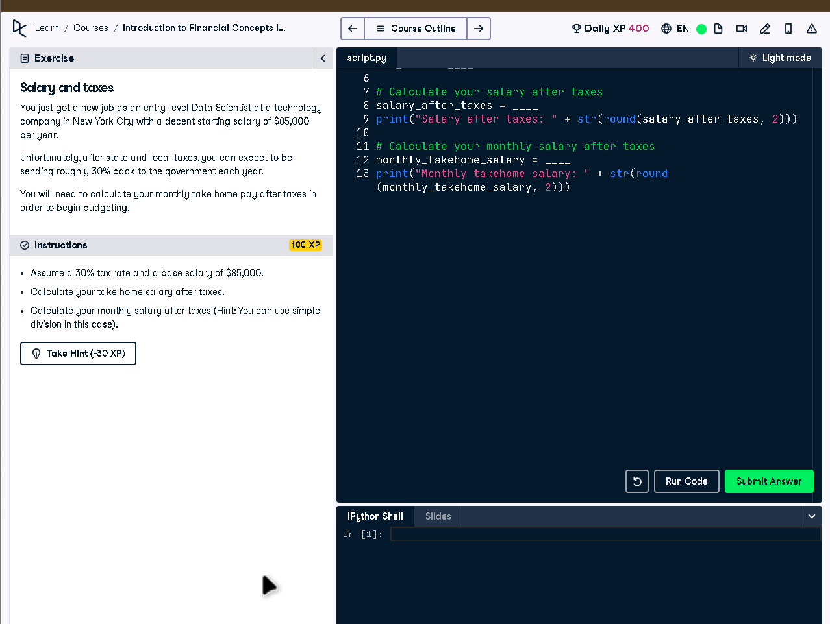

Full Code Answer:
# Enter your annual salary
salary = 85000
# Assume a tax rate of 30%
tax_rate = 0.30
# Calculate your salary after taxes
salary_after_taxes = salary*(1 - tax_rate)
print("Salary after taxes: " + str(round(salary_after_taxes, 2)))
# Calculate your monthly salary after taxes
monthly_takehome_salary = salary_after_taxes / 12
print("Monthly takehome salary: " + str(round(monthly_takehome_salary, 2)))

Question:
How do you calculate annual and monthly take-home salary after a 30% tax rate on a base salary of $85,000?

20-word Explanation (Question):
Tax reduces total income by 30 percent annually. Divide resulting amount by 12 to find monthly take-home pay after taxes.

Answer:
Use salary * (1 - tax_rate) for net salary, then divide by 12 for monthly after-tax income.

20-word Explanation (Answer):
Multiply salary by 70% for annual net, then divide by 12 to find how much you actually receive monthly.

